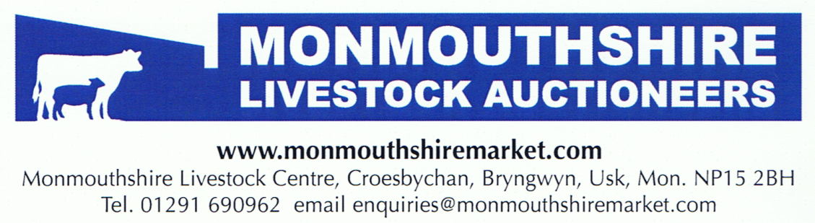
Show & Sale of North Country Cheviot Inlamb Ewes & Ewe Hoggs
Saturday 24th January 2026
A super entry of 177 head for the 2026 Sale.

The Sale kicked off with the Hill type, and some very pleasing returns! Mr C King, Rowleys sold his Champion to 400gns (yearling ewe, scanned twins), with another to the same money, then again at 300gns. AT & PR Jones, Clytha sold aged ewes, scanned 150% to 320gns & 280gns. There was however opportunity to buy bunches of strong Hill type sheep at what looked good value.
Park ewes encountered strong competition throughout, particularly on the best types and more of these could have been sold.
Top price of the day went to the Sale Champion, a yearling ewe from Mr KO Stones, Nun Cote Nook, which sold at 950gns to Tomos Williams, Muriau. A great bunch of yearlings from first time vendor Mr Jonny Orrells, Severnside created plenty of interest and topped at 720gns. Mr Ben Baker, BB sold ewes to 700gns & 650gns, along with A Sandle, Spring Bank also at 700 & 650gns. A large proportion of ewes traded from 350-550gns, with very little under 300gns.
There was plenty of trade for the smartest ewe hoggs. The 1st prize winner from Mr KO Stones selling at 850gns to the Judge Mr Luke Holmes. A Sandle also sold to 850gns. The smarter hoggs generally 300-500gns, more commercial types 160-250gns.

AVERAGES
AV MAX
PARK AGED EWES (26) £489 £735
PARK YLG EWES (32) £460 £998
PARK EWE HOGGS (22) £323 £893

HILL AGED EWES (28) £204 £336
HILL YLG EWES (5) £345 £420
HILL EWE HOGGS (12) £116 £116

🏆 SHOW RESULTS 🏆
JUDGE – LUKE HOLMES, CRAIGYBANK

Park Aged Ewe
1st - B Baker, BB
2nd - KO Stones, Nun Cote Nook
3rd – KO Stones, Nun Cote Nook
4th - Meakins & Sloyan, Y Beudy

Park Yearling Ewe
1st - KO Stones, Nun Cote Nook
2nd – KO Stones, Nun Cote Nook
3rd – A Sandle, Spring Bank
4th - J Orrells, Severnside

Park Ewe Hogg
1st – KO Stones, Nun Cote Nook
2nd – KO Stones, Nun Cote Nook
3rd – B Baker, BB
4th - B Baker, BB

CHAMPION – KO STONES (Yearling ewe)
RES CHAMPION – B BAKER, BB (Aged ewe)

Hill Aged Ewe
1st – C King, Rowleys
2nd - GG & HE Sevenoaks, Parc Lodge
3rd – AT & PR Jones, Clytha
4th - B Baker, BB

Hill Yearling Ewe
1st – C King, Rowleys
2nd - C King, Rowleys
3rd - GG & HE Sevenoaks, Parc Lodge
4th - GG & HE Sevenoaks, Parc Lodge

Hill Ewe Hogg
1st - GG & HE Sevenoaks, Parc Lodge
2nd -P Hulburd, Islay
3rd – P Hulburd, Islay
4th - GG & HE Sevenoaks, Parc Lodge

CHAMPION – C KING, ROWLEYS (Yearling ewe)
RES CHAMPION – C KING, ROWLEYS (Aged ewe)

Thank you to all vendors, purchasers & staff for contributing to another successful days trading.

Auctioneer: PHIL JONES

